Arad Contemporary Art Center

Sinkholes

Curator: Hadas Kedar

The exhibition 'Sinkholes' takes place at the Arad Contemporary Art Center, ninety years after a severe earthquake hit the Dead Sea area. The 6.25 Richter scale earthquake occurred on July 11, 1927, and resulted in 500 casualties and about 700 wounded people in Palestine-Eretz Israel and Jordan. Residents in the upheaval area described the sea in their diaries as "a site of tremendous boiling and severe waves."
The horrifying quake, at the turn of the previous century, was part of a chain of topographic changes that started 25 million years ago, when the African and the Asian tectonic plates began to move away from each other. The movements led to the formation of the Syrian-African rift, which runs from southern Turkey to Tanzania, and passes through the Dead Sea – the lowest terrestrial place in the world.
The exhibition 'Sinkholes' explores a unique phenomenon in this region: the land occasionally opens its mouth and swallows soil, sand, stones, objects, roads and even people.
Sinkholes is a long-known geological phenomenon, that appeared along the Dead Sea a few decades ago. These concavities that suddenly emerge in the salty soil are the results of an ongoing dissolving process of an underground salty layer. Yet, this phenomenon doesn't necessarily occur only due to natural circumstances. Sinkholes may also occur because of manmade activities, such as mining sites, pumping groundwater, construction works, broken pipe systems, etc. This phenomenon is considered a real danger due to the unexpectedness of these concavities and their size.
The exhibition deals with the curse of hubris, mankind's sin of vanity – the excessive human domineering of nature. The exhibited artworks deal with the primitive human fear of suddenly sinking into subterranean depths. By inviting the visitors on a journey into the deepness of their bodies and souls, the exhibition creates a kaleidoscope of our collective fears: trembling, sinking, swallowing, collapsing, extracting, phenomena that stimulate the power of imagination.
The works in this exhibition provide a Richter scale that indicates a fearful and undermined existentiality. They go deep into the abyss of our being, while examining the effervescing materials of its interiority. These artworks delve into the depths of our existence while coming in contact with its most elementary materials – the steaming core of its essence and to uncover the tenacious, consistent and monotonous principles of the primal existential element.
The exhibition 'Sinkholes' suggests art as a sinkhole: a pocket air, a burp in our challenging life sequence; a sudden space of yearning and fear in which the unknown dwells. The artworks exhibited tread on soft ground, exploring the persistent, consistent and monotonous principles of the primal existential element. They find themselves in black holes, where they connect to other dimensions – parallel universes, sites connoted with fantasy films and science fiction books.
The force that created these dramatic holes – the annihilation of nature by mankind – produced a grotesque phenomenon that arouses repulsion, curiosity, and astonishment. We may not be certain of the destiny of this dark creature, but we cannot doubt its rising presence in our day and age.

The title of Keren Benbenisty's kinetic installation Avec le vide, les pleins pouvoirs ('With the Void, Full Powers') relates to two well-known creators: the artist Yves Klein and the writer Albert Camus. During his artistic career, Klein aspired to find an artistic "container" for a "spiritual" space. Monochromatic painting was his initial attempt to accomplish this mission. Klein's combination of monochrome and exclusive use of blue (a color he patented under 'Klein's International Blue') was another step toward a spiritual space. In his 1958 exhibition 'The Void' Klein presented an empty displaying space, and at the opening ceremony, he served blue cocktail to his 3,000 guests, including Albert Camus who signed the guest book: "With the Void, Full Powers."
The exhibition's title and its connotation with Klein's cocktails lead to reconsideration of Benbenisty's installation – a glass constantly filling up and pouring with blue liquid – as a statement about the void, the Sisyphean attempt to fill it, and its inevitable emptying.

Michal Gilboa David's sculptural installation deals with the empty space and one's discomfort in encountering it. Gilboa David works in traditional minimalist sculpture tradition by situating a series of similar monochromatic units on the floor of the exhibition site. But in addition to her reference to minimalism, a field dominated mostly by male sculptors such as Judd, Flavin, Kelly and LeWitt, Gilboa David vividly examines negative spaces. The English sculptor Rachel Whiteread, famous for her artistic interest in empty spaces, exhibited a concrete casting of the interior of a three-story residential building in a London neighborhood. Gilboa David presents interior castings that are designated to transform the fear of void into an arena of playful relationships between shapes and volumes. The negative space of the interior of an array of containers is a metaphor for dealing with what does yet exist yet, or that which has already existed .

Ronny Hardliz's video art 'Unoccupied Territories' focuses on the hole in its physical and philosophical dimensions. It includes three video channels. The first channel shows a group of young people who are engaged in what appears to be digging a hole. This event takes place at the garden of the Arad Artists Residency Program's house. The action raises moral questions: does the group of youngsters know what the pit is meant for? What were the orders they received and who gave them the orders? Despite the pleasant temperament of these young people, it is impossible to avoid morbid thoughts about the possibility that this hole can contain a human body, and the fact that the action is taking place in the dark.
In the second part of the work, Hardliz crawls into the pit made by the young people in the previous channel. The different photography angle creates an illusion that Hardliz climbs up towards his own absorption in the hole. The third channel shows the site of the events that occurred in the previous two channels, but the site now appears to be static, motionless.
In deconstructing the action into three parts, Hardlitz redeems the action from its specificity, and stimulates to thoughts regarding the hole as simultaneously political and poetic.

Sari Carel turns paper into a sculptural device. She engraves in the soft paper and creates traces of action on its surface. She creates signs that indicate the transformation of the material in her studio – from a complete and consistent unit into a decayed material whose surface has been scratched and excavated. Like sinkholes, a phenomenon that is both natural and manmade, Carel's artwork undergoes a series of invasive interventions in the natural material.

The video ‘The Fourth Pole’ by Julia Wirsching & Gabriel Hensche
takes us on an expedition made by the artists to claim an unexplored terrain. The Fourth Pole is – in contrast to the Third Pole Mount Everest – the lowest dry point on the Earth. Located in an area that was previously part of the Dead Sea, the Fourth Pole is the result of the shrinking Dead Sea level. Hensche and Wirsching explore the post-apocalyptic landscape equipped with instruments traditionally used for territorial expansion as well as contemporary technology of surveillance and warfare. Thus ‘The Fourth Pole’ unfolds a timeless narrative that investigates territorial sovereignty as well as the desire to become an explorer in a widely documented and recorded world. (Text by Tomke Braun)

Hadas Satt's video-work 'Sinkholes' turns the viewer into a witness of photographed apocalypse of nature. On first glance, 'Sinkholes' seems like a program broadcasted on the National Geographic Channel. On second glance, one realizes it as a parody of these televized nature programs: a decline of small stones brings on a rockslide which accelerates into a collapse of whole mountains, which then leads to the collapse of millions-year-old tectonic plates.
The realization that the photographed events are actually made by Satt – a deliberate rolling of stones on the edge of the Dead Sea – uncovers the inherent paradox in human-nature relationship. The photographic tricks that seem to be taken from science fiction 'B movies' refer to the toll of the ambivalent relationship between human and nature: the same nature that expresses a transcendental beauty is also a site for interventions, disruption of natural processes and making of a human mark.

Dana Levy has filmed the two video channels in her installation 'Monolith' at three different sites: the Dead Sea beaches, Death Valley, and Lake Mono in California. Levy settles herself in the space-like landscape and manipulates it. She projects beams of light, she blows bubbles, and she splashes sand. Levy projects these interventions on rocks placed in the gallery - one rock shows her interventions in daytime, while the film screened on the other rock was shot in the dark.
In the Anthropocene era, the current geological period that marks a stage in which the contemporary human influence on Earth reached a point of no return requires a reconsideration of what we consider as "land art." Whereas Robert Smithson ('Spiral Jetty') and his contemporaries preferred large-scale works that demanded the use of great amounts of energy, today's "land art" looks for methods to minimize the use of energy. Hence, Levy's artwork places cheap affects and technology at the center of her work, offering it as a substitute for strong physical actions in the landscape.

Nir Harel presents a selection of digitally printed drawings as hammocks hanging from the ceiling. By inviting the viewers to use his paintings as a place to lay their bodies, Harel considers art not only as a platform for observation on the environment, but also as a site for swirling, stripping, and fading within the environment.
The hammocks shield and surround the viewers while enabling them to delve in a private space within the public sphere. The range of issues dealt with by the observer-participant comprises thoughts about composition, color, shape, and instrumental aspects such as weight, height and speed of the artwork.

Santiago Sierra in his video art '3,000 holes 180x50x50 each', presents a high angle photograph of a perforated area. The work was created on the shores of Morocco, opposite to the Gibraltar Strait, and it deals with the daily struggle of Africans who immigrate to Europe.The holes were dug by a group of workers of African origins. The dimensions of the holes are connoted with graves. In their location on the coast between Spain and Africa, they make us conscious of the dangers faced by illegal immigrants.
In addition to the discussion of emigration, Sierra seeks to reflect the slavery conditions of the immigrants, who yearn to reach European countries. They try to fulfill their dream by digging holes for a minimum wage. This artwork gazes at this phenomenon and exposes the unjust exploitation of the immigrants by the Europeans.

In a world dominated by food corporations, there's a need for a different logics of food consumption that is not produced by the market. In 'Climavore' by Cooking Sections (Daniel Fernández Pascual & Alon Schwabe), a perforated horizontal slab hanging from the ceiling turns toward the Climate is the leading actor. Occasionally, during the exhibition, this board functions as a platform for eating. The holes along the "table," however, make it difficult to eat. They were made according to a map of current sinkholes along the shores of the Dead Sea. In these meals, Cooking Sections offer five food seasons of the Climavore that aim to overcome the overuse of natural resources. The length of these seasons vary and extend over weeks, months, years and decades: the forever fertile season, the drought season, the invasive season, the season of ocean cleaning, and the season of the deserts.

Yair Perez's paintings introduce the viewer to ephemeral occurrences that range from early primordial moments to apocalyptic and terminal occurrences. The painted scenes show universal creatures who look like outcast of a chemical apocalypse that merged atoms and molecules in a fertilizing fluid.
Bright and radiant colors, as well as the frantic brush strokes, create a radioactive environment. Perez paints deformed, deviant, clumsy, freaky and abnormal figures that lack natural proportions. They continue to interact with the environment while absorbing its poison. Possible inspired by the Hiroshima and Chernobyl children, they are cut off, inflated and mutated in their environment.

Gilad Ratman's video art 'Boogieman' is named after its protagonist who gradually disappears into a muddy soil. This work is an anthology of videos shot by Boogie man, an Internet persona.
The work presents Boogieman's psychological relations with the muddy land. Boogieman's acting and photography are so compelling that the horrified viewer bids him farewell and congratulates him on his return - over and over. Like the characters in von Trier's The Idiots and Herzog's Grizzly Man, Boogieman is released from societal restrictions through his unmediated encounter with nature. He plunges into the heart of the earth, and he stays there until his body is almost completely submerged.
Seemingly, Ratman chooses to present Boogyman as a sort of his own alter ego. Ratman, whose works demonstrate a primitivist-barbaric spirit, deals in this work with the terrestrial uncanny who disappears into the earth. He offers the viewers to reconsider art as an experience of delving into tunnels and underground passages, and the humans' merging with the material, to the point of uninhibited release.

Shiri Shalmy's artwork focuses on a 'folly', an architectural structure built for decorative purposes, without any architectural function other than improvement of the area. Despite the title of this work, the viewer is drawn to look inside a polygonal showing device.
The video that is screened inside the structure reflects the point of view of a body moving inside a sinkhole. At first, this body is in the swallowing chamber of the sinkhole. Then it undergoes the curves and twists of what appears to be the sinkhole's digestive system, and finally it reaches the bottom of the sinkhole. This work enables the spectator to experience one of the most horrifying routes.
Another artwork by Shalmy, 'Untitled (a Sinkhole)', in a flat replica of a 100-meter sinkhole that emerged in 2007 in the middle of a street in Guatemala City. This sinkhole became an Internet sensation and is emblematic for urban sinkholes.
Translated by Gilad Padva

https://vimeo.com/43965570
Hadas Set
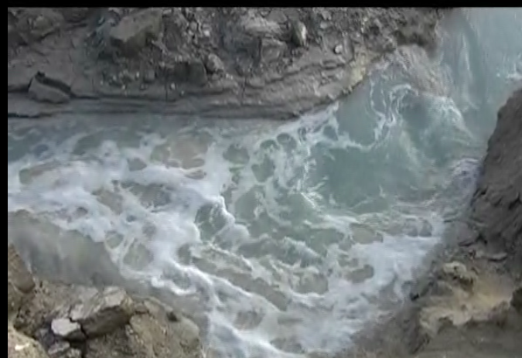

Gilad Ratman
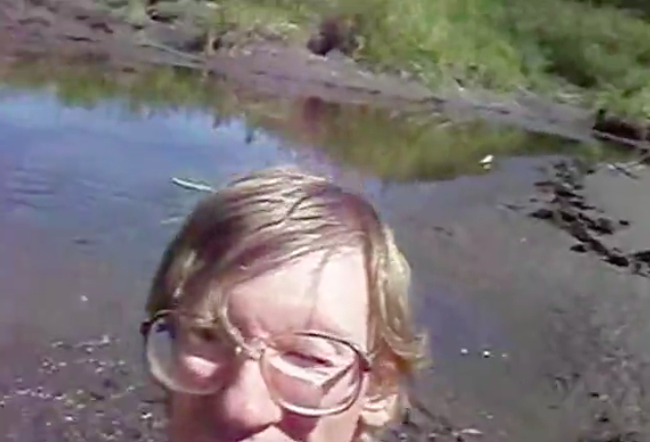

Dana Levy – Projection on stones
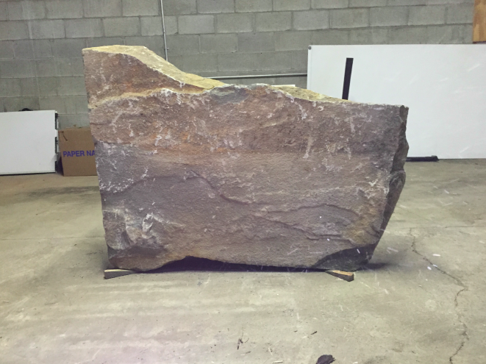

Shiri Shalmy
https://www.youtube.com/watch?v=r4FJmFMJjEU&feature=em-share_video_user

Michal Gilboa David – a sculpture
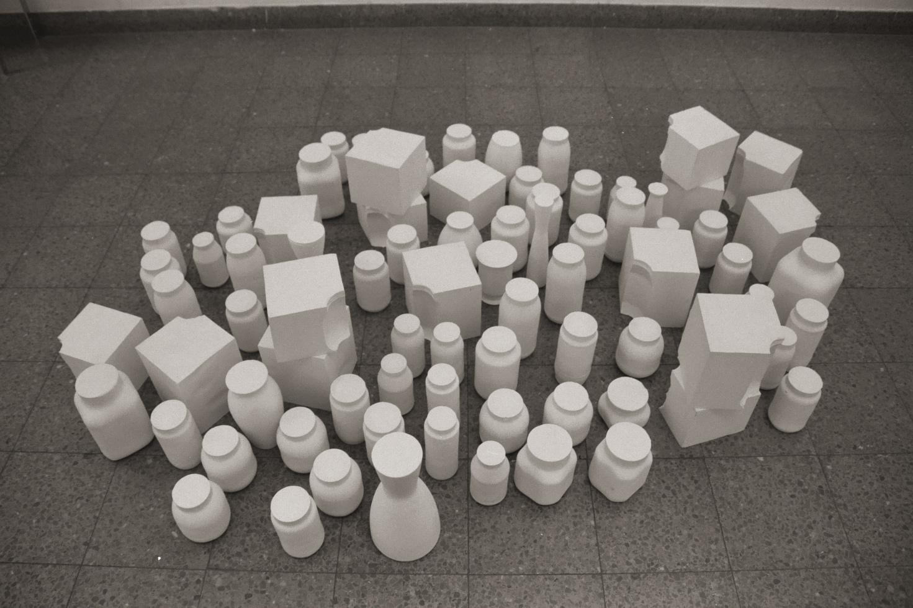י

Alon and Daniel's Cooking Sections
'Climavore'
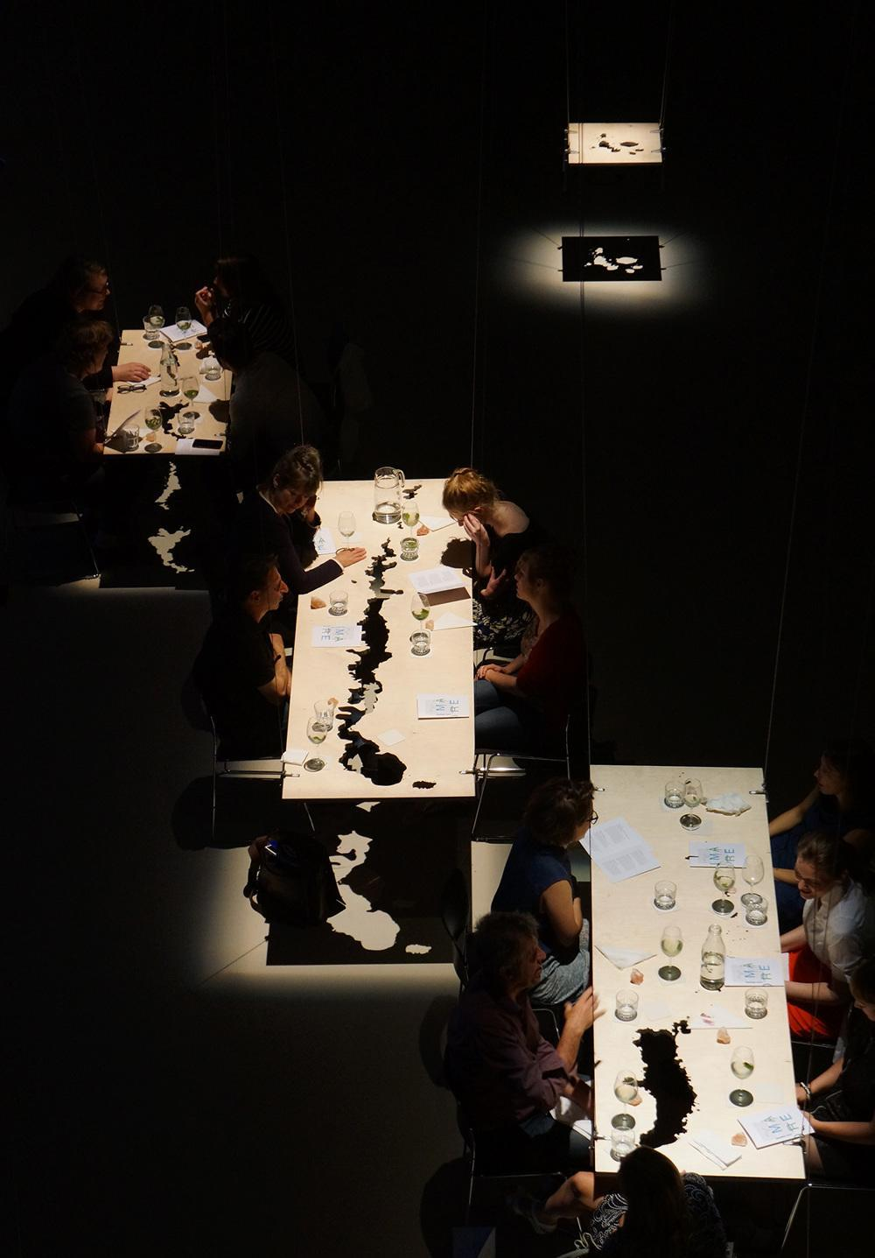

Keren Benbenisty
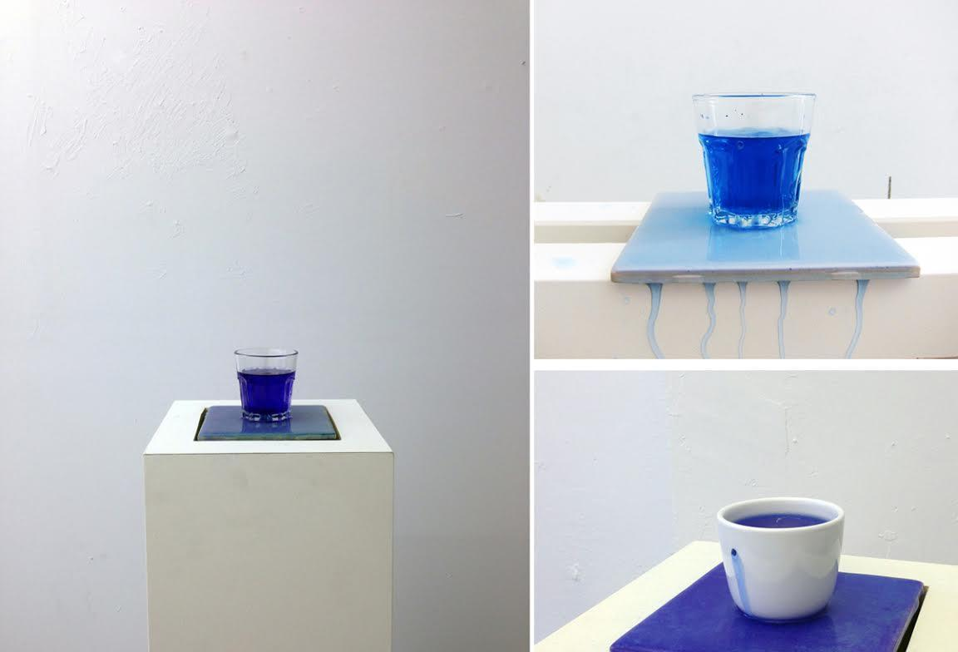

Nir Harel
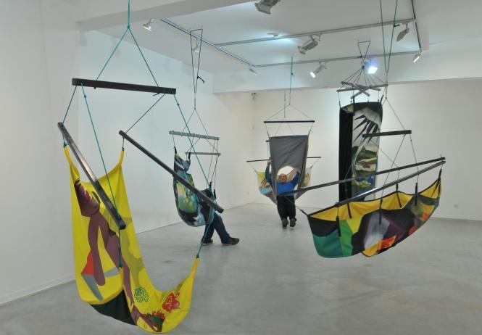

Yair Perez
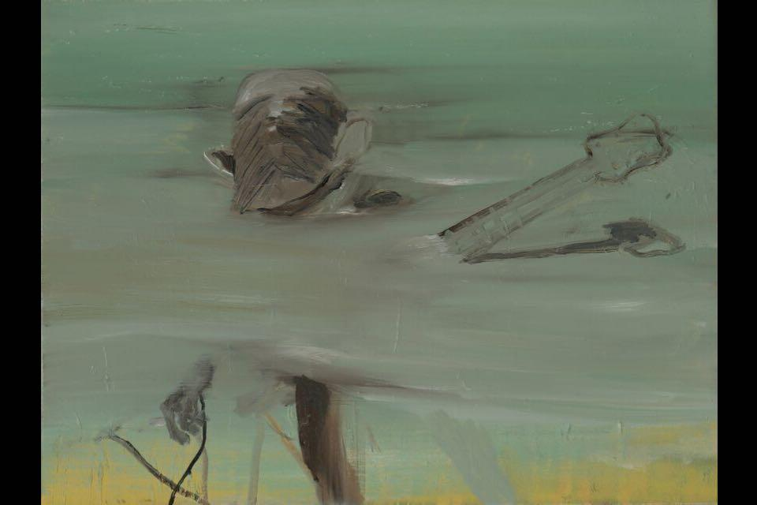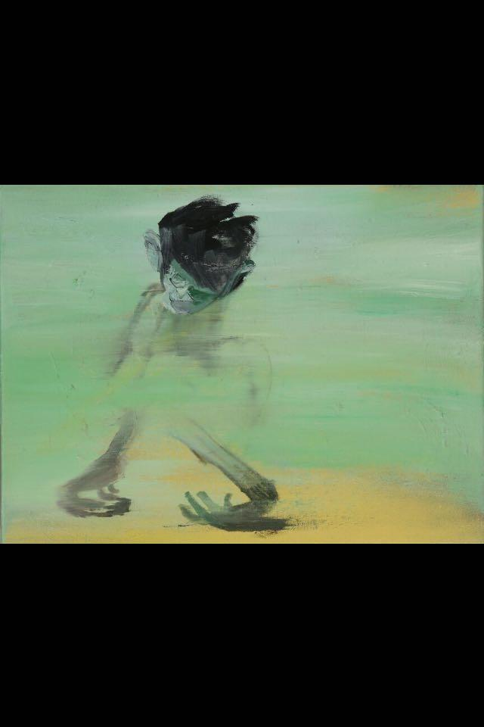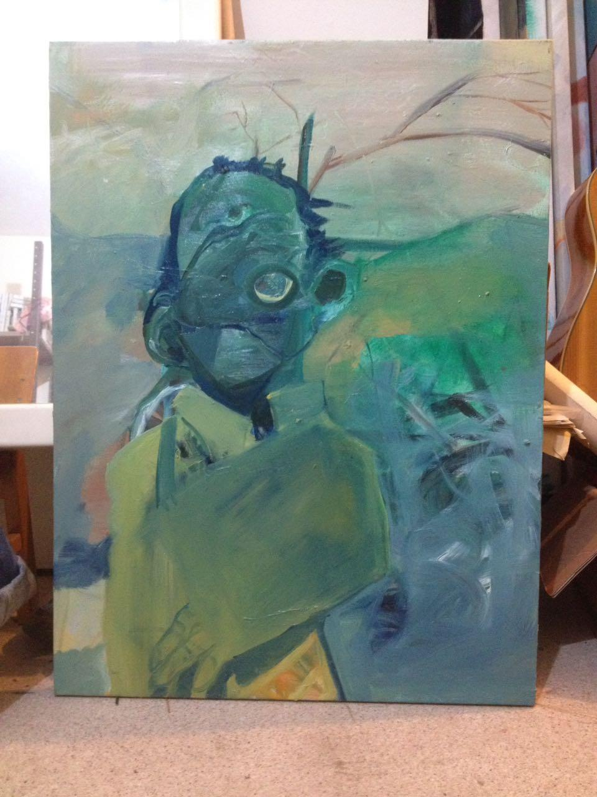
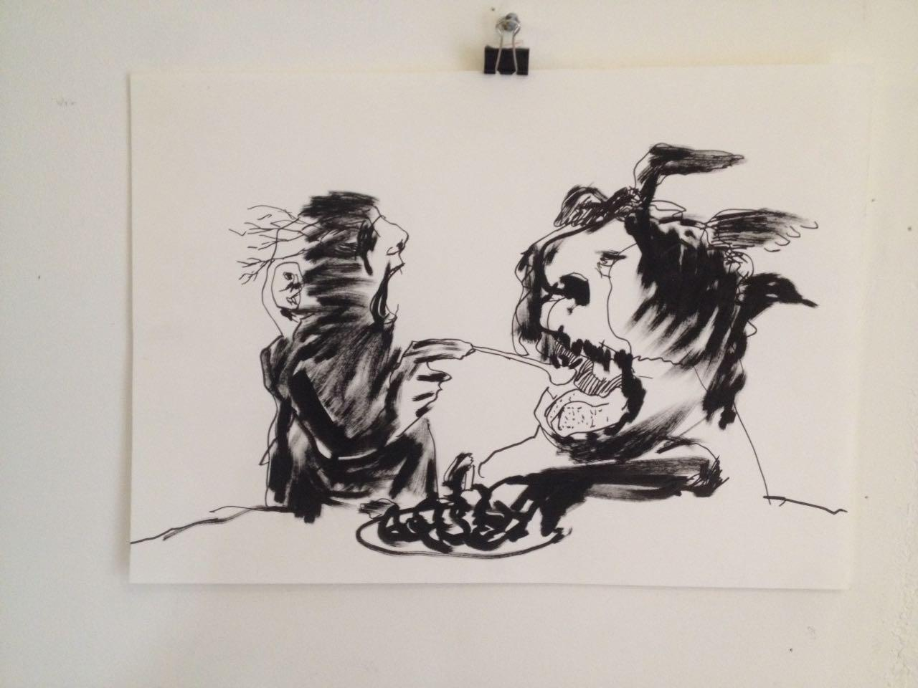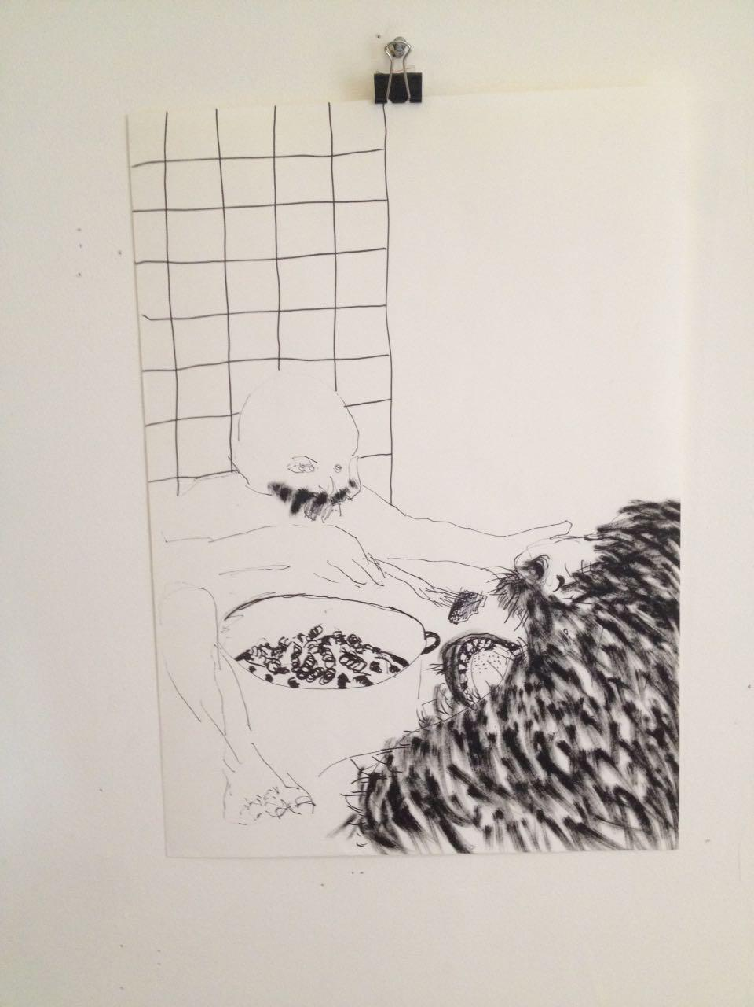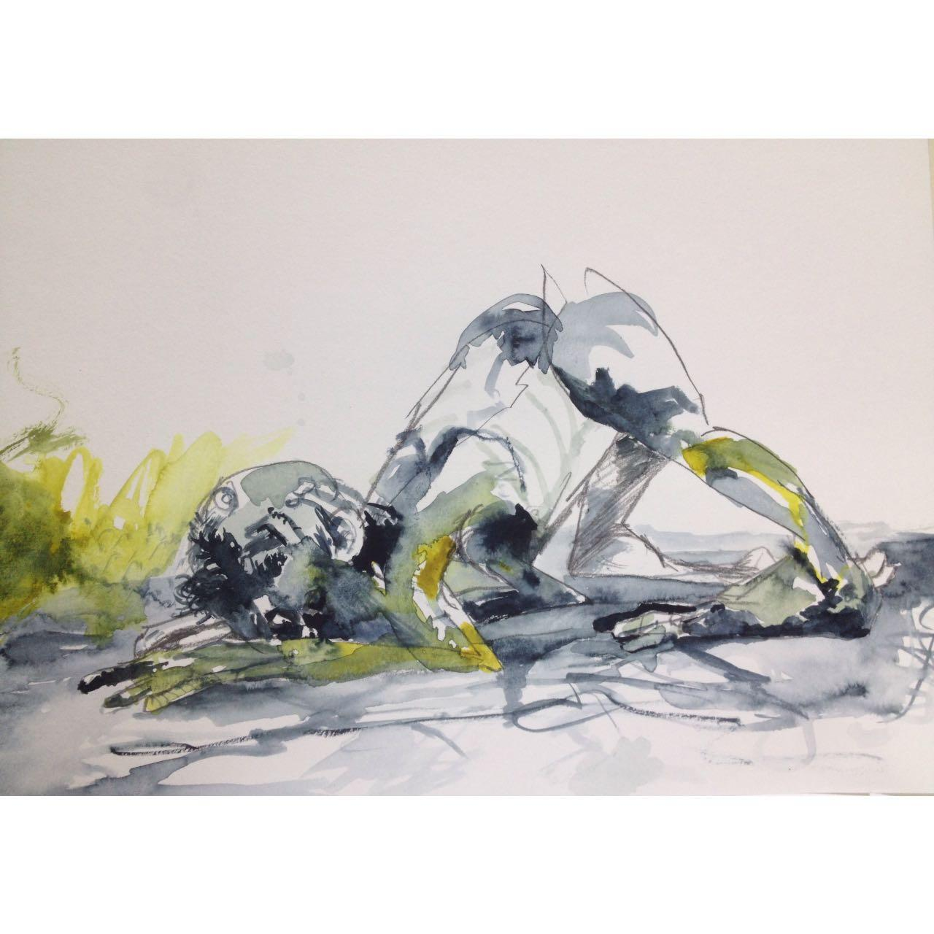
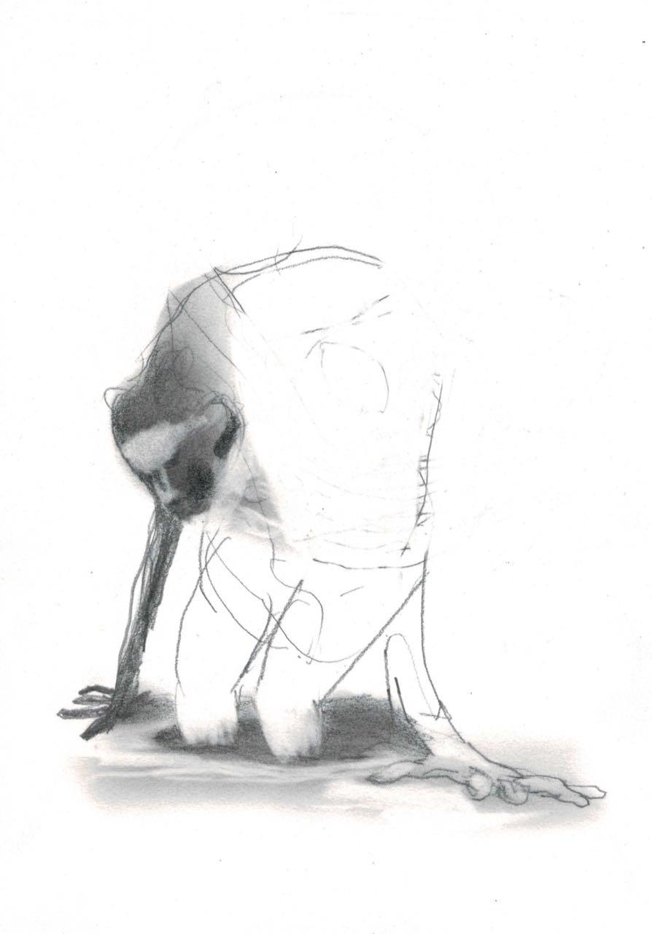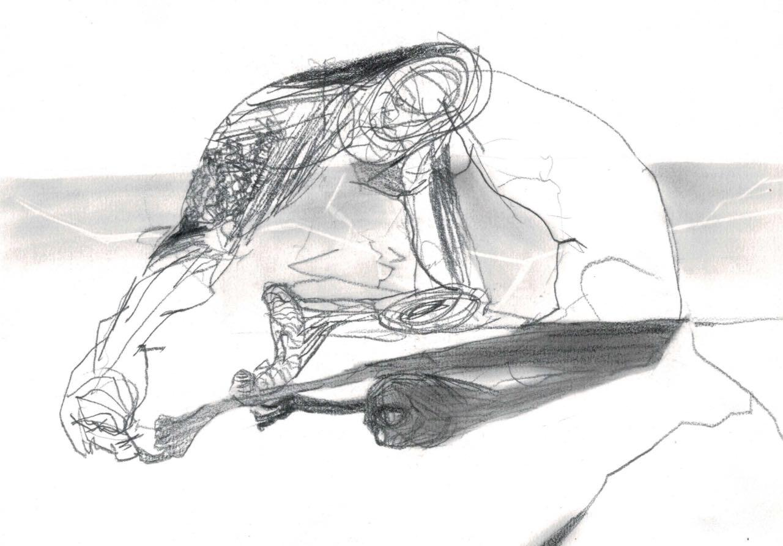

Sari Carel

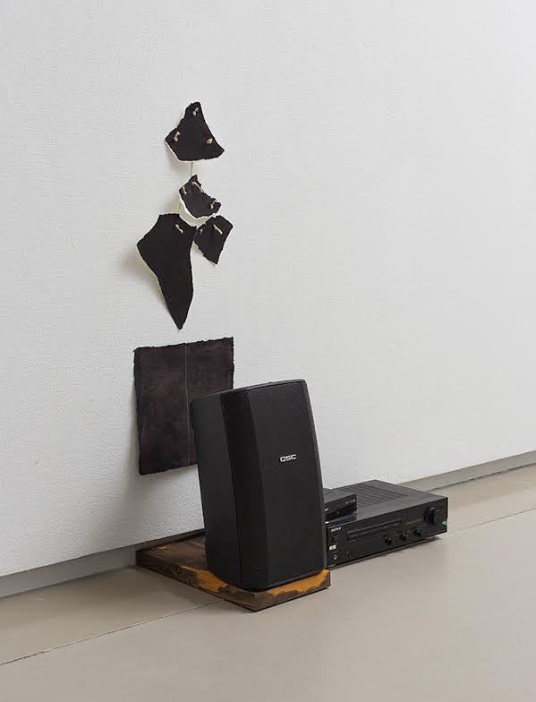

Performance:
Dan Alon
'Coocking Sections'

